**Final report**

**Reported by Zhou Zhengyu 3230110840**

**& Yao Yijiang 3230111876**

1. **Introduction**

Our project aims to address the challenge of creating a music-responsive car that not only follows a designated track but also adjusts its speed in response to musical input. This car serves as a platform to explore the integration of audio signal processing with motor control systems, providing a dynamic and interactive experience.

The design concept involves three main systems: an IR Detector System for track following, a Speed Control System for motor regulation, and an Electret Microphone System for audio signal capture and processing. These systems are interconnected through an AND logic structure to ensure cohesive operation. The car's response to music is realized by modulating the motor speed based on the intensity of the audio signal detected by the microphone.

Inputs: The system takes in audio signals through the Electret Microphone and positional data from the IR Detector to stay on track.

Outputs: The primary output is the adjusted motor speed, controlled by the Speed Control System, which in turn influences the car's movement along the track.

1. **Analysis of** **Components**

**IR Detector System:** The IR Detector is characterized by its sensitivity to the contrast between the track and its surroundings. Measurements were taken to determine theoptimal distance from the track for accurate detection. Fig1. A oscilloscope image is provided, showing the output (Vdd for white, GND for black) in relation to the 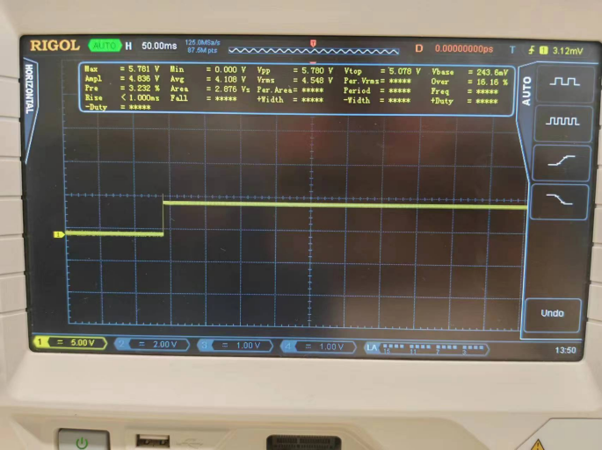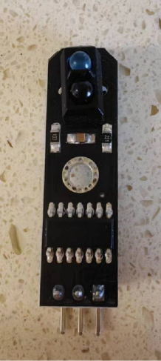detector's position above the track.

Fig1. IR detector physical picture & a oscilloscope image of IR Detector

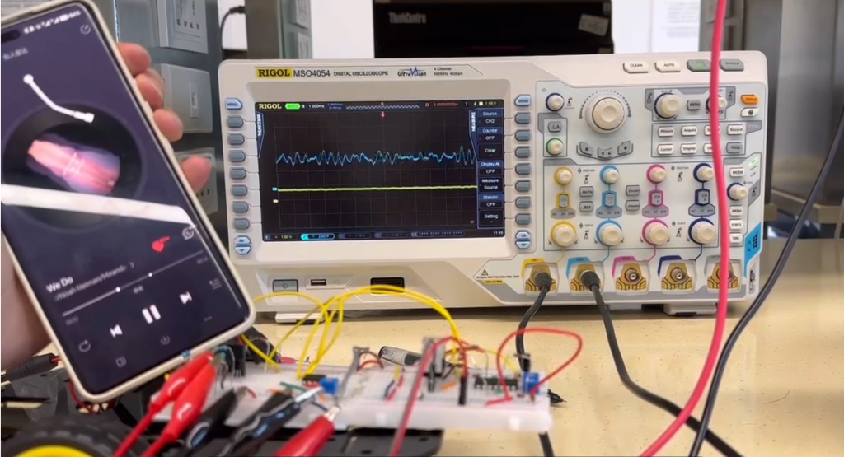**Electret Microphone System:** The microphone's output signal was characterized for different sound intensities. An amplification circuit using a BJT was designed to boost the weak signal from the microphone to a level suitable for processing by the LM311 Voltage Comparator. Fig2. A graph is included to illustrate the relationship between sound intensity and the resulting electrical signal.

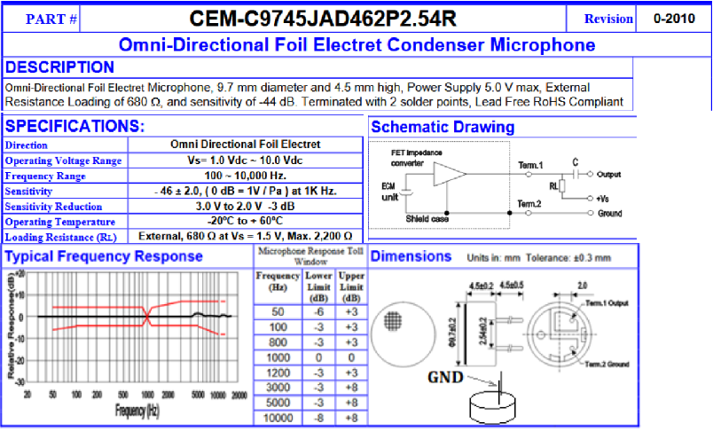

Fig2. Data sheet of Electret Microphone & Comparison of electrical signal before amplification and signal after amplification

**LM311 Voltage Comparator:** This component was tested to ensure its ability to convert the amplified audio signal into a binary output that can be used to modulate the car's speed. The reference voltage was adjusted to find the threshold at which the comparator's output changes state.

**Linear Voltage Regulator IC L7805CV:** This regulator is used to lower the voltage of the batteries, which is 7.6V to 5V, the appropriate operating voltage of most sensors on our car. Part of its datasheet is shown here.

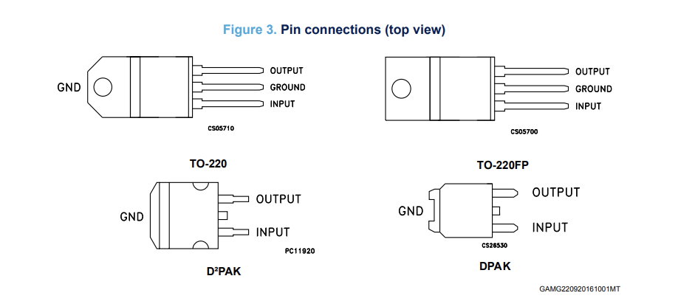

Fig.3 Part of the Datasheet of L7805CV, taken from st.com

With this device, we can easily protect our sensors and keep the components of our vehicle running properly.

**Components Design Considerations**

* Placement of Sensors: The IR Detector's placement was critical for maintaining track accuracy. After several iterations, it was determined that mounting the detector close to the track, using extension screws, provided the most reliable detection.
* Signal Processing: The sensitivity of the audio signal to noise from the motors was a significant challenge. To overcome this, the microphone was isolated from other components, and its signal was amplified to ensure clarity.
* Motor Control: The Speed Control System was designed to receive input from both the IR Detector and the Electret Microphone System. The use of PWM signals allowed for precise control over motor speed, which was essential for the car's responsive behavior.

1. **Design consideration**
2. Block diagram and explanation

The graph depicted in Figure 3 serves as the comprehensive schematic representation of the circuit design, effectively translating the three components proposed in the block diagram.

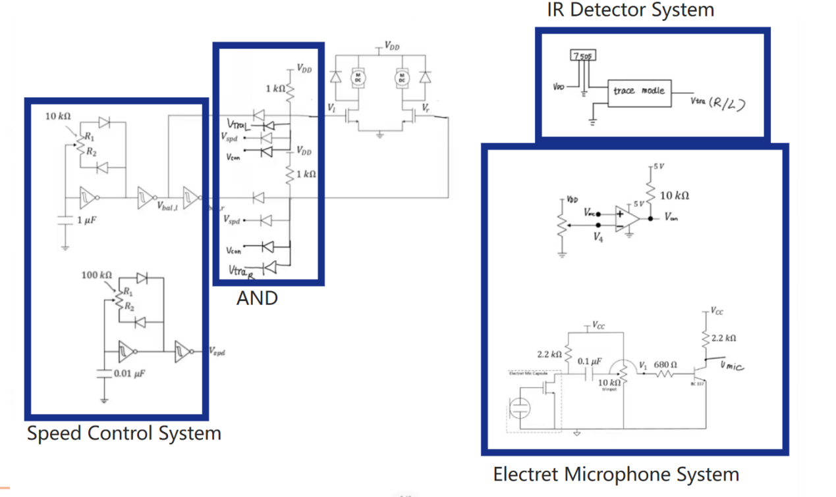

Fig.4 Complete circuit design

* IR Detector System: Responsible for detecting the track and ensuring the car stays on the designated path.
* Speed Control System: Employs two PWM signals: one for motor balancing and another for speed control.
* Electret Microphone System: Captures audio signals, particularly music, and processes it for the motors.

All these systems are connected by an AND structure. So these functions can workded together to control the motors.

1. Circuit schematic and explanation
2. IR Detector System

Our car's rail tracing system operates with a 7.6V Vdd, but the tracing module requires 5V, which we achieve using an L7805 regulator. The module outputs Vdd for white and GND for black. As the rail is black, the signal is connected directly to the MOSFET G node via a diode-based AND gate, eliminating the need for signal inversion and ensuring the car stays on track.

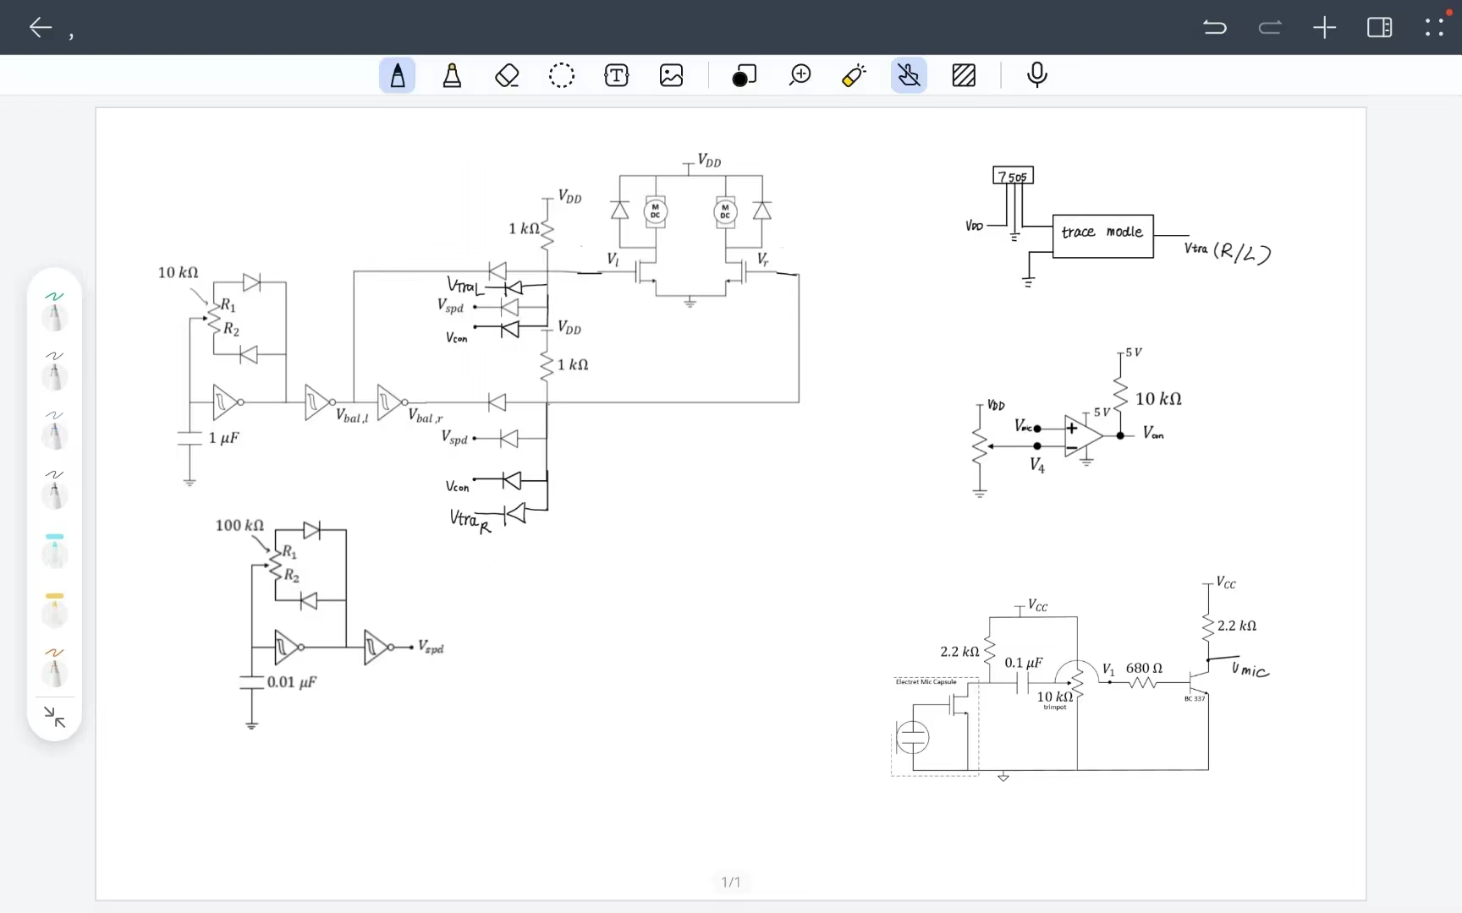Fig.5 IR Detector System Schematic

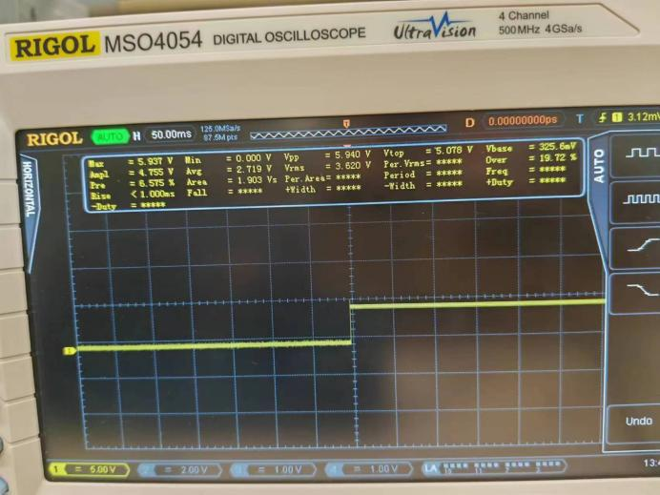Fig.6 the output of the IR Detector System: left output is GND when detecting black, right is Vdd when detecting white

1. Speed Control System

The speed control system, derived from prior labs, employs two PWM signals: one for motor balancing and another for speed control. A potentiometer adjusts the balance PWM's duty cycle, while inverted signals are fed to each motor to synchronize their speeds. The speed PWM provides the same signal to both motors, enabling uniform acceleration or deceleration by varying its duty cycle.

Fig.7 Speed Control System Schematic

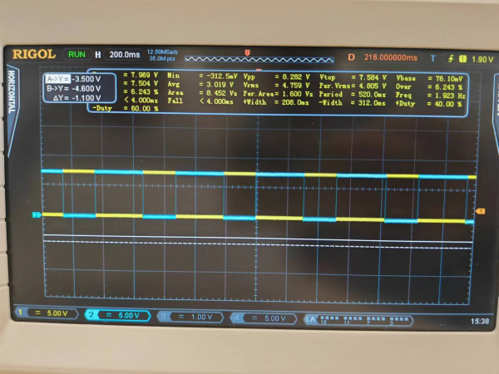Fig.8 the Balancing Signal Waveform

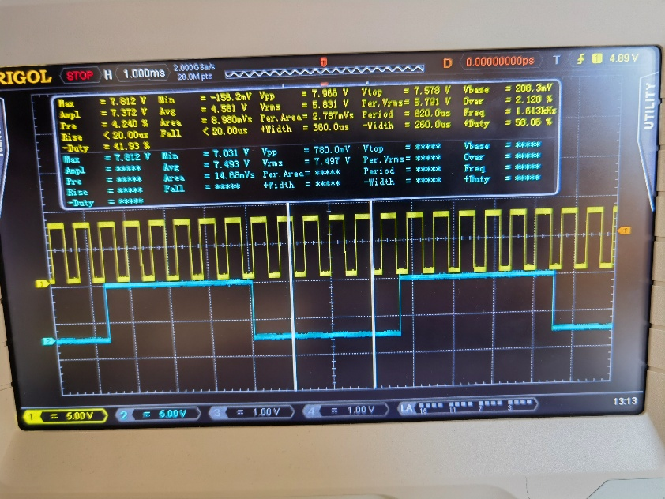Fig.9 the Balancing Signal Waveform (Blue)

1. Electret Microphone System

The Electret Microphone captures sound and converts it into an electrical signal. This weak signal is amplified using a Bipolar Junction Transistor (BJT) and then fed into an LM311 Voltage Comparator. The comparator output is a binary signal that correlates with the music's intensity, which is used to modulate the car's speed.

Fig.10 Electret Microphone System Schematic

As the figure shown above, V4 is the reference voltage we set. If the input signal, which is the signal generated by amplified microphone circuit. If Vmic is greater than V4 which is the reference voltage, the LM311 Voltage Comparator’s output is 5V.

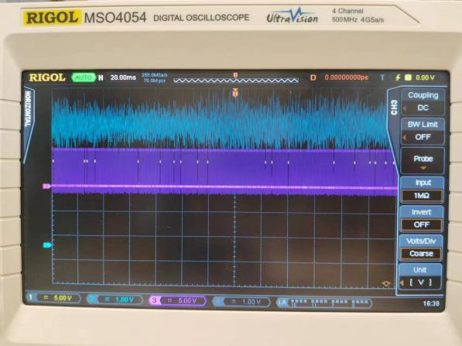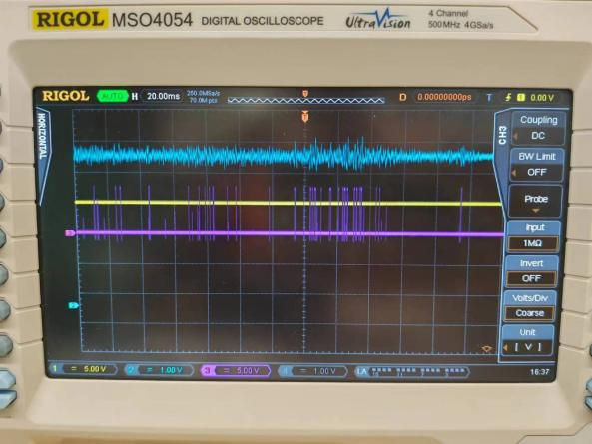  
Fig.11 the output of the LM311 Voltage Comparator (Violet); input of the LM311 Voltage Comparator (Blue); reference voltage (Yellow)

This design makes operation of motors more secure and stable. Additionally, the comparator also amplifies the output voltage and let us easily adjust the comparison voltage.

1. Physical/mechanical construction

The IR Detector is mounted underneath the car, facing the track. It is secured with extension screws to make sure that it can be closer to the track. This design can increase the accuracy when detecting the track.

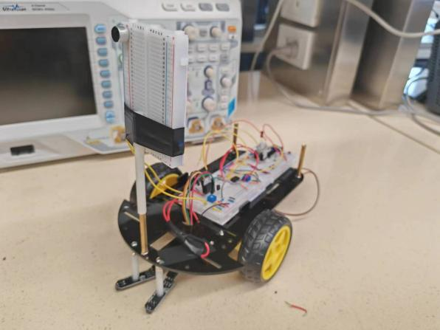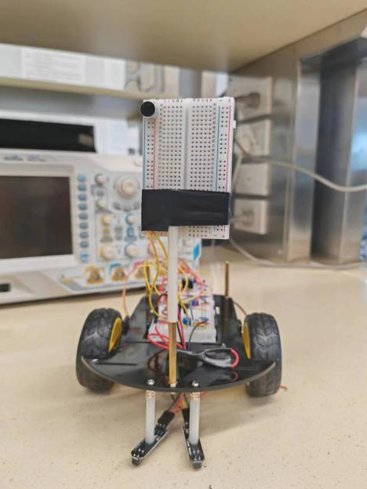The Electret Microphone is positioned at the front of the car, ensuring it captures the music signal clearly. It is was installed in a stick protruding from the chassis.

Fig.12 side view Fig.13 front view

1. **Conclusion**
2. Lessons learned

During the design and construction of our music-responsive car, we have encountered several unexpected challenges. Here are some of the key obstacles we faced and the strategies we employed to overcome them.

First of all, the oscilloscope was crucial in debugging our circuitry and understanding the behavior of our signals. The scope's ability to display the temporal behavior of signals allowed us to pinpoint the faulty component and replace it with a functional one. The real-time feedback provided by the oscilloscope was crucial. It allowed us to make incremental changes to the circuit and immediately see the effects, which accelerated the debugging process. Trough the use of oscilloscope, we found one node of the Smith trigger is damaged.

Second, about detector sensitivity. The IR detector’s sensitivity to track color is significant challenge. We conducted extensive testing. We adjusted the distance between the ground and the detector. We also isolated our microphone from other components to enhance the sensitivity, reducing the disturb from the noise produced by motors.

Finally, a circuit design is important before conducting the car. It is the fundamental to design a successful car.

1. Self-assessment

Reflecting on the project, we believe that our design has met the objectives set out in the introduction. The car is capable of autonomously following a track in response to music. However, we recognize that there is room for improvement, particularly in the areas of detector’s sensitivity. Throughout the project, we encountered various challenges, from signal processing to motor control issues. This problem-solving process really strengthened our understanding of the basic knowledge in circuit designing, and we benefited a lot.